
Technological Institute of the Philippines
938 Aurora Boulevard Cubao, Quezon City

ITE 010 – INTRODUCTION TO HUMAN-COMPUTER INTERACTION
Discussion 3.1 Interface Styles

Name: Aristotle Buenaventura
Section: IT12S1

Find at least five (5) software applications that you have experience using. Identify the interface styles used in the software application.
- Netflix

Netflix is a web-based feature that offers a wide assortment of grant winning TV shows, motion pictures, anime, narratives, and more on great many web associated gadgets. You can look however much you need, at whatever point you need without a solitary business – just for one low month to month cost.
- Menu
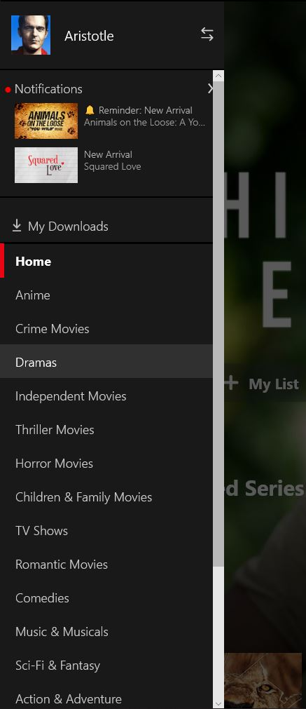

- Form filling
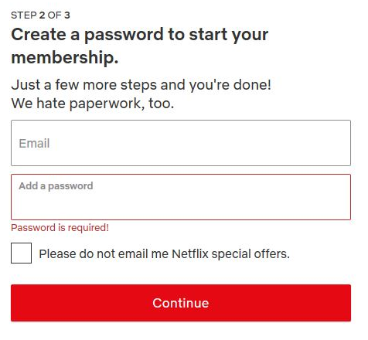

- Function keys
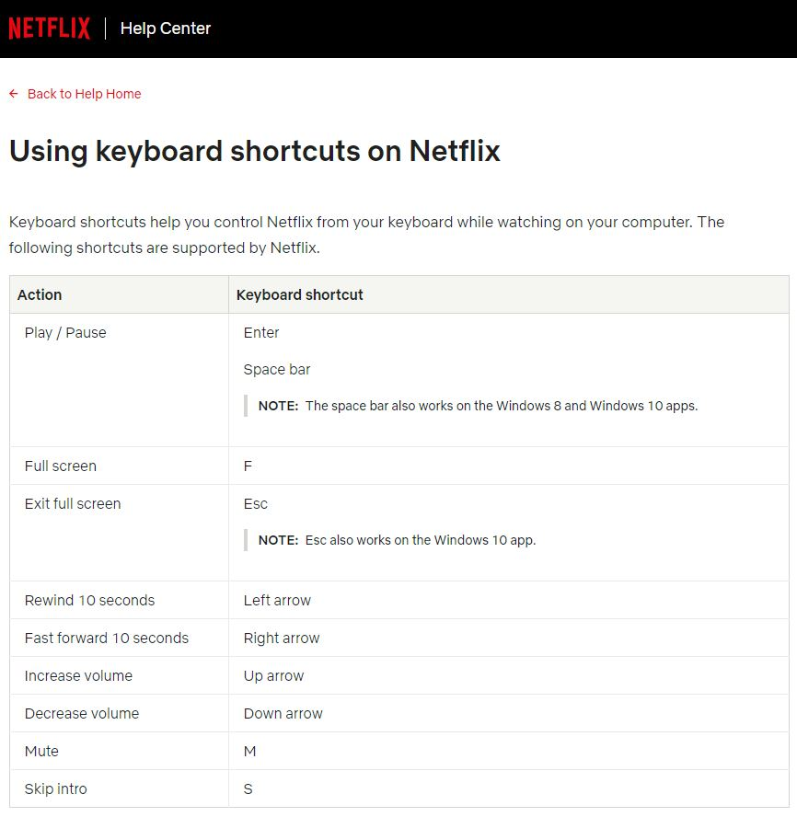

- Graphical direct manipulation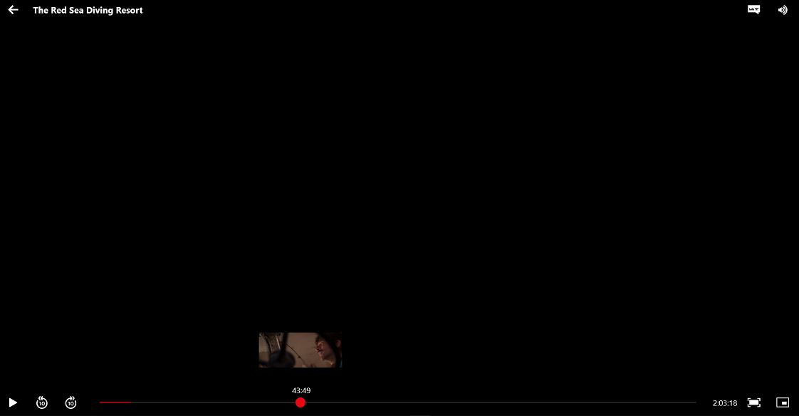
- Question and answer / Point and click
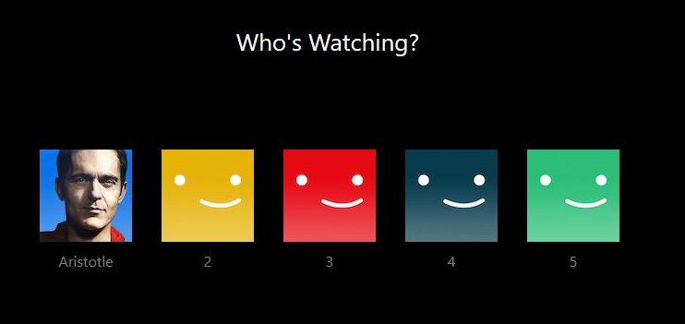


- Spotify
Spotify is a digital music, podcast, and video streaming service that gives you access to millions of songs and other content from artists all over the world.

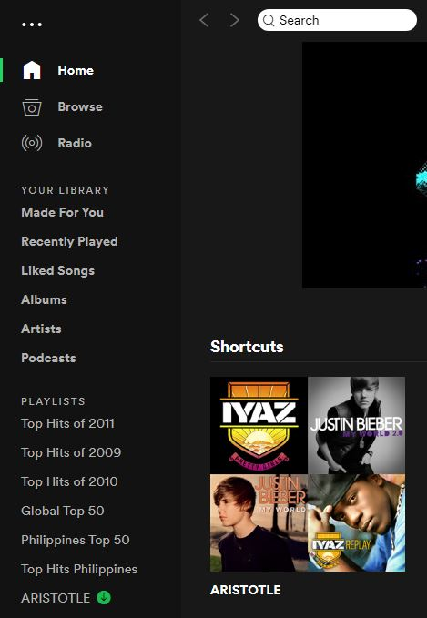
- Menu

- Form filing
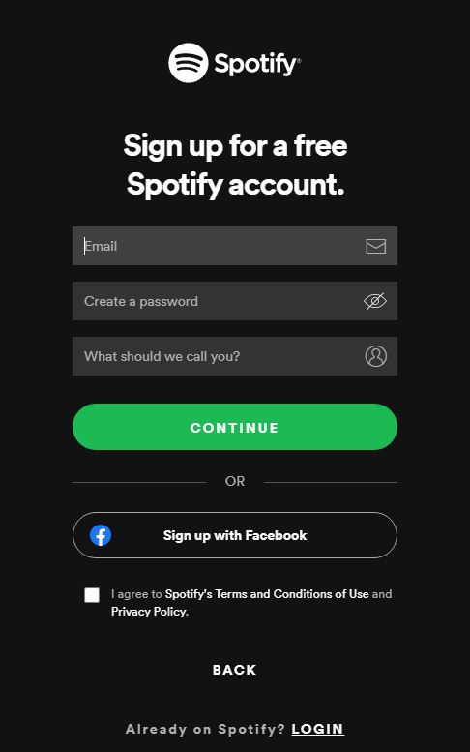

- Graphical direct manipulation


- Merriam-Webster
The Merriam-Webster.com Dictionary is a unique, regularly updated, online-only reference. Although originally based on Merriam-Webster's Collegiate Dictionary, Eleventh Edition, the Merriam-Webster.com Dictionary has since been significantly updated and expanded with new entries and revised definitions.

- Menu
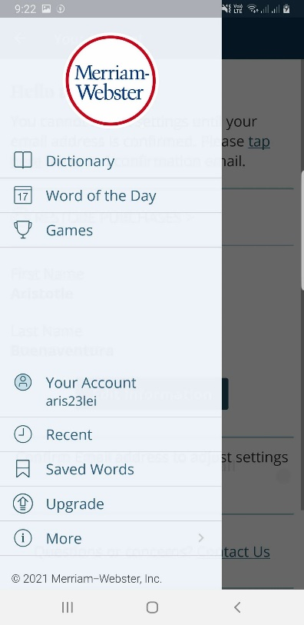

- Form filling

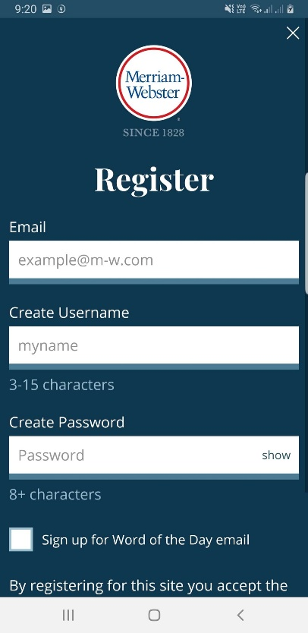

- Natural language (Voice recognition)
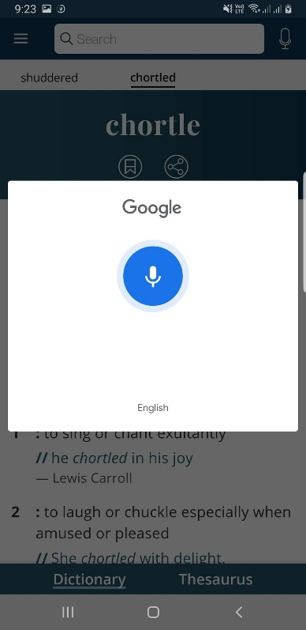

- Point and click
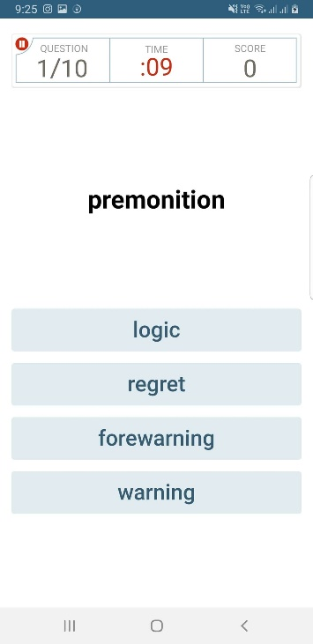


- Messenger
Facebook Messenger is a FREE mobile messaging app used for instant messaging, sharing photos, videos, audio recordings and for group chats. The app, which is free to download, can be used to communicate with your friends on Facebook and with your phone contacts.
- Menu
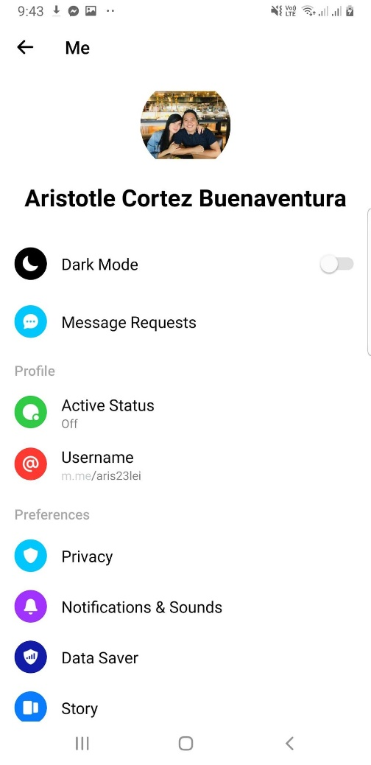

- Graphical direct manipulation
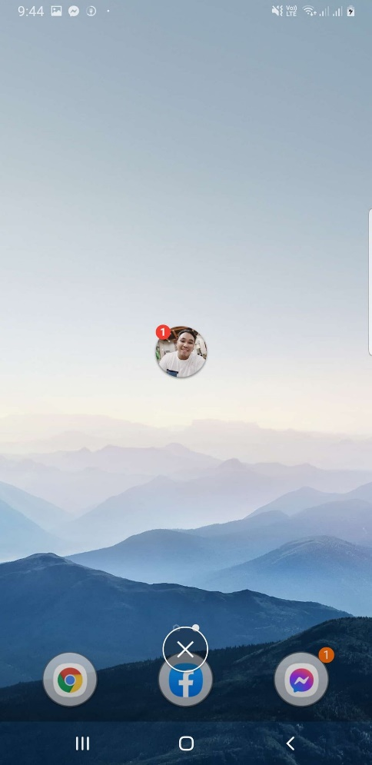

- Point and click
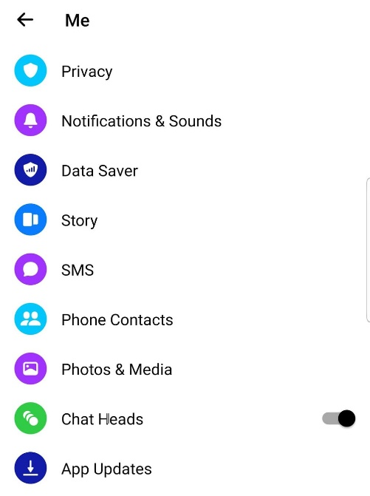

- Form filling
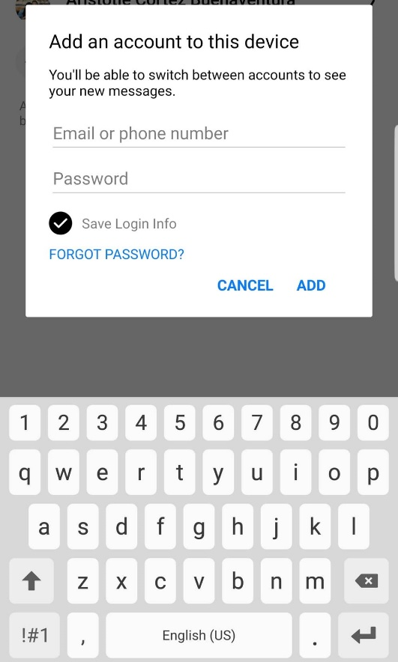

- GCash

GCash is a digital wallet that holds your money, plain and simple. Each amount in the wallet has an equivalent amount of peso in real life. You put your money into it, and the cash being digital makes it easy to do transactions with it, empowering the user to leverage it to do work without as much effort.

- Menu
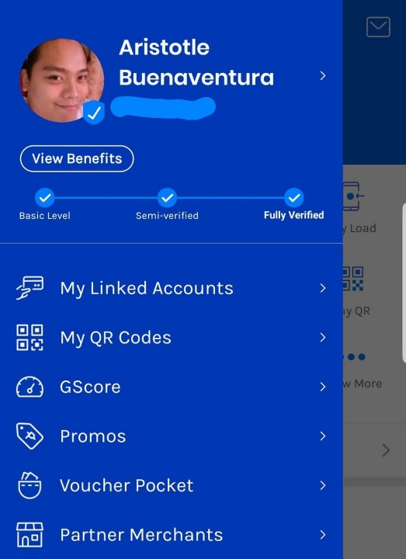

- Form filling
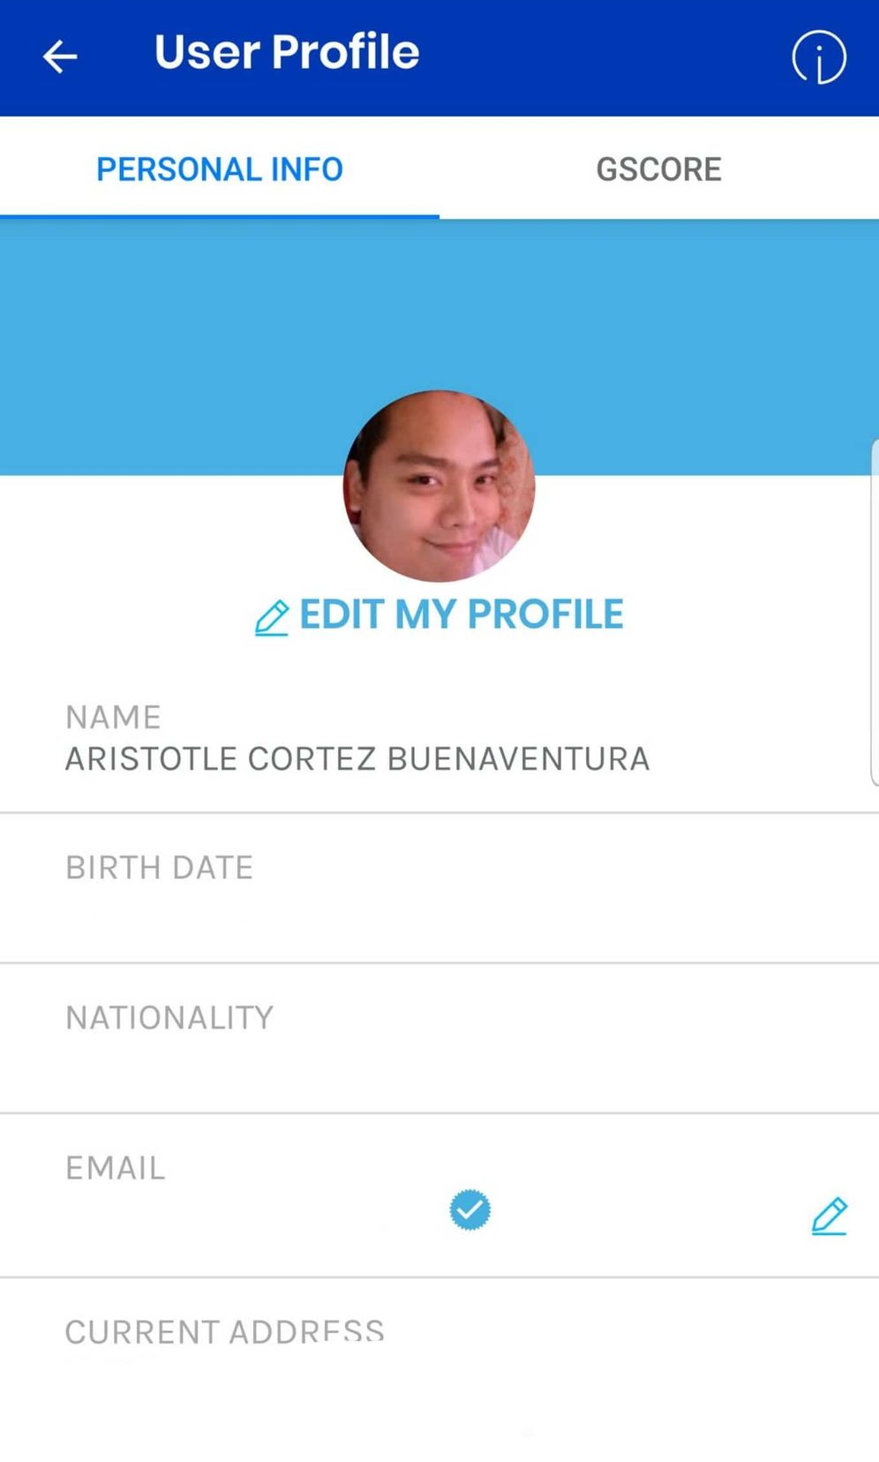

- Point and click
